CEBU INSTITUTE OF TECHNOLOGY
UNIVERSITY

COLLEGE OF COMPUTER STUDIES

Software Project Management Plan
for
Earthquake Analyzer

Signature

_________________________
Marvin Joshua P. Chewchut
Team Leader
Project Analysis

_________________________
Keith Joseph B. Damandaman
Data Analysis
Programmer

_________________________
Clark Jay R. Cortezano
Lead Programmer
Program Designer

Change History
Revision # | Changes | By | Date
1.0 | Added External Structure  Added Internal Structure  Added Roles and Responsibilities | Clark Jay R. Cortezano | September 27, 2018
1.1 | Added Purpose, scopes, and objectives  Added Assumptions and constraint  Added Project Deliverables | Clark Jay R. Cortezano | October 03, 2018
1.2 | Added Preface  Added Definitions  Added Start up Plan  Added Control Plan  Added Supporting Process Plan | Clark Jay R. Cortezano | October 07,2018
1.3 | Added Process Model  Added Method, Tools, and Techniques | Clark Jay R. Cortezano | October 09, 2018
1.4 | Revised Preface.  Improved technical Process and supporting process plan. | Keith Joseph B. Damandaman | October 10, 2018

Preface

Earthquakes are one of the most dangerous natural disaster on Earth especially to the infrastructures. It would be nice if we could monitor the seismic behavior of the earth’s crust when there is an earthquake. Today, we have the technology to do make that with come true. Unfortunately, here in the Philippines, we still have to import this technology to the country and the price of this technology is nothing to laugh at. This is where the Earthquake analyzer comes into play.

Table of Contents

Contents
Signature 2
Change History 3
Preface 4
Table of Contents 5
List of Figures 6
List of Tables 7
1.Overview 8
1.1. Project Summary 8
1.1.1. Purpose, scope and objectives 8
1.1.2. Assumptions and constraints 8
1.1.3. Project deliverables 8
1.1.4. Schedule and budget summary 8
1.2. Evolution of plan 12
2.References 13
3. Definitions 14
4.Project organization 15
4.1. External structure 15
4.2. Internal structure 15
4.3. Roles and responsibilities 16
5.Managerial process plans 17
5.1. Start-up plan 17
5.1.1. Estimation plan 17
5.1.2. Staffing plan 17
5.1.3. Resource acquisition plan 17
5.1.4. Project staff training plan 17
5.2. Work plan 17
5.2.1. Work activities 17
5.2.2. Schedule allocation 21
5.2.3. Resource allocation 21
5.2.4. Budget allocation 21
5.3. Control plan 21
5.3.1. Requirements control plan 21
5.3.2. Schedule control plan 21
5.3.3. Budget control plan 21
5.3.4. Quality control plan 22
5.3.5. Reporting plan 22
5.3.6. Metrics collection plan 22
5.3.7. Risk management plan 22
5.3.8. Project closeout plan 22
6. Technical process plans 23
6.1. Process Model 23
6.2. Methods, tools, and techniques 24
6.3. Infrastructure Plan 24
6.3. Product Acceptance Plan 24
7. Supporting process plans 25
7.1. Configuration management plan 25
7.2. Verification and validation plan 25
7.3. Documentation plan 25
7.4. Quality assurance plan 25
7.5. Reviews and audits 25
7.6. Problem resolution plan 25
7.7. Subcontractor management plan 25
7.8. Process improvement plan 25
8. Additional Plans 26
9. Index 27

List of Figures

Figure | Name | Page No.
Figure 4.1.1 | External Structure | 15
Figure 4.2.1 | Internal Structure | 15
Figure 6.1.1 | Process Model | 23

List of Tables

Table | Name | Page No.
Table 1.1.4.1 | Requirements Schedule | 8
Table 1.1.4.2 | Implement 1 Schedule | 9
Table 1.1.4.3 | Implement 2 Schedule | 9
Table 1.1.4.4 | Implement 3 Schedule | 10
Table 1.1.4.5 | Implement 4 Schedule | 10
Table 1.1.4.6 | Implement 5 Schedule | 11
Table 1.1.4.7 | Implement 6 Schedule | 12
Table 4.3.1 | Roles and Person(s) Responsible | 16
Table 4.3.2 | Roles and Responsibilities | 16
Table 5.2.1.1 | WBS Requirements | 17
Table 5.2.1.2 | WBS Implement 1 | 18
Table 5.2.1.3 | WBS Implement 2 | 18
Table 5.2.1.4 | WBS Implement 3 | 19
Table 5.2.1.5 | WBS Implement 4 | 19
Table 5.2.1.6 | WBS Implement 5 | 20
Table 5.2.1.7 | WBS Implement 6 | 21
Table 6.2.1 | Methods and Techniques | 24
Table 6.2.2 | Tools Used | 24

Overview

Project Summary

1.1.1. Purpose, scope and objectives
This project is intended for planning, managing, and scheduling purposes and also to know more and have a skills in management about these said purposes for the team members. It serves as a document for target deliverables expected from each team member.

1.1.2. Assumptions and constraints
This project assumed to be finished before the end of the semester. All codes are implemented in Android studio using Java programming language and XML. This application operate Android version IceCreamSandwich.

1.1.3. Project deliverables
The project will produce an android application called EarthquakeAnalyzer. EarthquakeAnalyzer is an android application which allows the user to use their android phone as an instrument to detect earthquake. It uses an internal sensor namely accelerometer and the orientation sensor that keep track if there is an earthquake or not. It also analyzes the given data if the earthquake detected and outputs hypocenter and direction.

1.1.4. Schedule and budget summary
Task Name | Duration | Start | Finish | Resource Names
Requirements
Define Problem | 2 hrs | 7/10/2018 | 7/10/2018 | ALL
Pain Points | 3 hrs | 7/12/2018 | 7/12/2018 | ALL
Costumer Journey | 2 hrs | 7/17/2018 | 7/17/2018 | ALL
Empathy Map | 3 hrs | 7/19/2018 | 7/19/2018 | ALL
Positioning Map | 2 hrs | 7/24/2018 | 7/24/2018 | ALL
StoryBoard | 3 hrs | 7/26/2018 | 7/26/2018 | ALL
Paper Prototype | 2 hrs | 7/31/2018 | 7/31/2018 | ALL
Validation Survey | 2 hrs | 8/4/2018 | 8/4/2018 | ALL
SRS- USECASE | 2 hrs | 8/7/2018 | 8/7/2018 | ALL
SRS-PROTOTYPE | 3 hrs | 8/9/2018 | 8/9/2018 | ALL
Complete SRS document | 4 days | 8/10/2018 | 9/13/2018 | ALL
SPMP-WBS | 2 hrs | 8/14/2018 | 8/14/2018 | ALL
SPMP- ROLES/ORG CHART | 3 hrs | 8/16/2018 | 8/16/2018 | ALL
SPMP- PROCESS MODEL | 2 hrs | 8/17/2018 | 8/17/2018 | ALL
Complete SPMP document | 3 days | 8/18/2018 | 9/20/2018 | ALL

Table 1.1.4.1 Requirements Schedule
Task Name | Duration | Start | Finish | Resource Names
Implement 1
Installing software and  tools for the project | 2 hrs | 9/2/2018 | 9/2/2018 | ALL
Creating Use Case for DropDownView | 1 hr | 9/3/2018 | 9/3/2018 | Marvin Joshua Chewchut
Creating MVC  for DropDownView | 1 hr | 9/3/2018 | 9/3/2018 | Marvin Joshua Chewchut  Clark Jay Cortezano
Creating sequence  diagram for  DropDownView | 1 hr | 9/4/2018 | 9/4/2018 | Marvin Joshua Chewchut  Clark Jay Cortezano
Designing UI for  activity_drop_down_view | 1 hr | 9/6/2018 | 9/6/2018 | Clark Jay Cortezano
Coding for DropDownView | 1 hr | 9/6/2018 | 9/6/2018 | Clark Jay Cortezano
Testing of DropDownView | 1 hr | 9/6/2018 | 9/6/2018 | Clark Jay Cortezano

Table 1.1.4.2 Implement 1 Schedule

Task Name | Duration | Start | Finish | Resource Names
Implement 2
Creating Use Case for  CompassPage | 1 hr | 9/7/2018 | 9/7/2018 | Marvin Joshua Chewchut
Creating MVC for  CompassPage | 1 hr | 9/7/2018 | 9/7/2018 | Marvin Joshua Chewchut  Clark Jay Cortezano
Creating sequence  diagram for  CompassPage | 1 hr | 9/10/2018 | 9/10/2018 | Marvin Joshua Chewchut  Clark Jay Cortezano
Designing UI for  orientation | 2 hrs | 9/11/2018 | 9/11/2018 | Clark Jay Cortezano
Coding for  CompassPageView | 1 hr | 9/11/2018 | 9/11/2018 | Clark Jay Cortezano
Coding for  CompassPageController | 1 hr | 9/11/2018 | 9/11/2018 | Clark Jay Cortezano
Testing of  CompassPage | 1 hr | 9/11/2018 | 9/11/2018 | Clark Jay Cortezano

Table 1.1.4.3 Implement 2 Schedule

Task Name | Duration | Start | Finish | Resource Names
Implement 3
Creating Use case for  RealTimePage | 1 hr | 9/12/2018 | 9/12/2018 | Marvin Joshua Chewchut
Creating MVC for  RealTimePage | 2 hrs | 9/12/2018 | 9/12/2018 | Marvin Joshua Chewchut  Clark Jay Cortezano
Creating sequence  diagram for  RealTimePage | 2 hrs | 9/13/2018 | 9/13/2018 | Clark Jay Cortezano  Marvin Joshua Chewchut
Designing UI for  realtime | 3 hrs | 9/14/2018 | 9/14/2018 | Clark Jay Cortezano
Coding for  RealTimeView | 3 hrs | 9/15/2018 | 9/15/2018 | Clark Jay Cortezano
Coding for  RealTimeController | 3 hrs | 9/15/2018 | 9/15/2018 | Clark Jay Cortezano
Testing of  RealTimePage | 1 hr | 9/15/2018 | 9/15/2018 | Clark Jay Cortezano

Table 1.1.4.4 Implement 3 Schedule

Task Name | Duration | Start | Finish | Resource Names
Implement 4
Creating Use case for  LoadDataPage | 1 hr | 9/17/2018 | 9/17/2018 | Marvin Joshua Chewchut
Creating MVC for  LoadDataPage | 2 hrs | 9/17/2018 | 9/17/2018 | Marvin Joshua Chewchut
Creating sequence  diagram for  LoadDataPage | 2 hrs | 9/18/2018 | 9/18/2018 | Marvin Joshua Chewchut
Designing UI for  loaddata | 1 hr | 9/20/2018 | 9/20/2018 | Marvin Joshua Chewchut
Coding for  LoadDataView | 2 hrs | 9/20/2018 | 9/20/2018 | Marvin Joshua Chewchut
Coding for  LoadDataController | 3 hrs | 9/20/2018 | 9/20/2018 | Marvin Joshua Chewchut
Testing of  LoadDataPage | 1 hr | 9/20/2018 | 9/20/2018 | Marvin Joshua Chewchut

Table 1.1.4.5 Implement 4 Schedule

Task Name | Duration | Start | Finish | Resource Names
Implement 5
Creating Class Diagram  for DisplayGraph | 1 hr | 9/21/2018 | 9/21/2018 | Clark Jay Cortezano
Creating Class Diagram  for CSVFileDecoder | 1 hr | 9/21/2018 | 9/21/2018 | Marvin Joshua Chewchut
Creating Class Diagram  for EarthquakeAnalyzer | 1 hr | 9/21/2018 | 9/21/2018 | Marvin Joshua Chewchut
Creating Class Diagram  for EarthQuakeDataClass | 1 hr | 9/21/2018 | 9/21/2018 | Marvin Joshua Chewchut
Creating Class Diagram  for RecordSaveDataXYZ | 1 hr | 9/21/2018 | 9/21/2018 | Clark Jay Cortezano
Creating Class Diagram  for MediaRescan | 1 hr | 9/21/2018 | 9/21/2018 | Clark Jay Cortezano
Coding for  DisplayGraph | 4 hrs | 9/22/2018 | 9/22/2018 | Clark Jay Cortezano
Coding for  CSVFileDecoder | 3 hrs | 9/22/2018 | 9/22/2018 | Marvin Joshua Chewchut
Coding for  EarthquakeAnalyzer | 3 hrs | 9/22/2018 | 9/22/2018 | Marvin Joshua Chewchut  Keith Joseph Damandaman
Coding for  EarthQuakeDataClass | 3 hrs | 9/22/2018 | 9/22/2018 | Marvin Joshua Chewchut  Keith Joseph Damandaman
Coding for  RecordSaveDataXYZ | 3 hrs | 9/23/2018 | 9/23/2018 | Clark Jay Cortezano
Coding for  MediaRescan | 1 hr | 9/23/2018 | 9/23/2018 | Clark Jay Cortezano
Testing for  DisplayGraph | 1 hr | 9/24/2018 | 9/24/2018 | Clark Jay Cortezano
Testing for  CSVFileDecoder | 1 hr | 9/24/2018 | 9/24/2018 | Marvin Joshua Chewchut
Testing for  EarthquakeAnalyzer | 1 hr | 9/24/2018 | 9/24/2018 | Marvin Joshua Chewchut  Keith Joseph Damandaman
Testing for  EarthQuakeDataClass | 1 hr | 9/24/2018 | 9/24/2018 | Marvin Joshua Chewchut  Keith Joseph Damandaman
Testing for  RecordSaveDataXYZ | 1 hr | 9/24/2018 | 9/24/2018 | Clark Jay Cortezano
Testing for  MediaRescan | 1 hr | 9/24/2018 | 9/24/2018 | Clark Jay Cortezano

Table 1.1.4.6 Implement 5 Schedule

Task Name | Duration | Start | Finish | Resource Names
Implement 6
Testing of entire  application (finding error) | 2 hrs | 9/25/2018 | 9/25/2018 | Marvin Joshua Chewchut  Keith Joseph Damandaman
Code fixing (if error occur) | 5 hrs | 9/25/2018 | 9/25/2018 | Marvin Joshua Chewchut
Optimizing the code | 3 hrs | 9/26/2018 | 9/26/2018 | Marvin Joshua Chewchut
Final testing of  entire application | 1 hr | 9/26/2018 | 9/26/2018 | ALL

Table 1.1.4.7 Implement 6 Schedule

Evolution of plan
The updates of the plan will occur every week to adjust necessary adjustments for the project. The whole team is notified of the scheduled updates during school days.

References
https://developer.android.com/training/implementing-navigation/nav-drawer
https://www.simplifiedcoding.net/android-navigation-drawer-example-using-fragments/
https://www.javacodegeeks.com/2013/09/android-compass-code-example.html
https://www.youtube.com/watch?reload=9&v=XEfaJWa_GPg
https://www.youtube.com/watch?v=RcqXFxqIAW4
https://developer.android.com/guide/topics/sensors/sensors_overview

Definitions

Term | Definition
Accelerometer | An instrument for measuring acceleration.
Compass | A device that is used to find direction.
SPMP | Software Project Management Plan
SRS | Software Requirements Specification
MVC | Model View Controller

Project organization

External structure
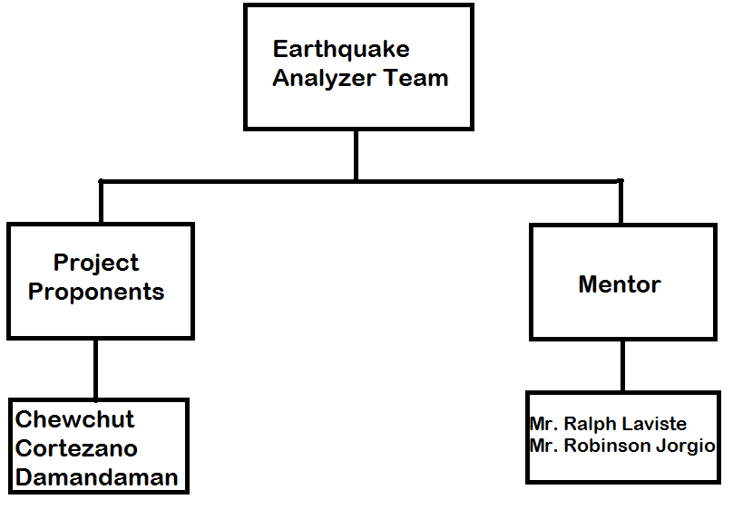

Figure 4.1.1 External Structure

Internal structure
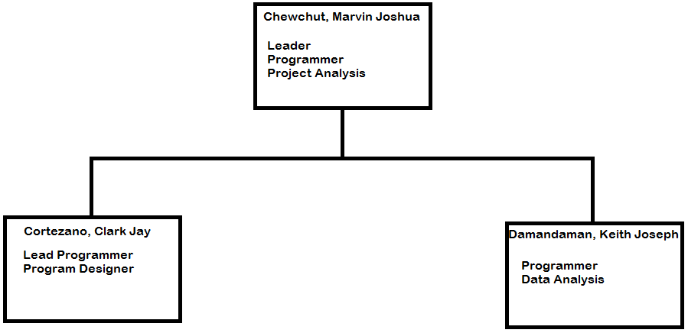
Figure 4.2.1 Internal Structure

Roles and responsibilities

Role | Person(s) responsible
Leader | Marvin Joshua P. Chewchut
Lead Programmer | Clark Jay R. Cortezano
Data Analysis | Keith Joseph B. Damandaman
Program Designer | Clark Jay R. Cortezano
Program Analysis | Marvin Joshua P. Chewchut
Programmer | All Members

Table 4.3.1 Roles and Person(s) responsible
Role | Responsibilities
Leader | Software project planning and monitoring  Milestone and schedule planning and monitoring  Set and communicate the team meeting agendas.  Maintain Project log book.
Programmer | Program the project
Lead Programmer | The Branch master of the program
Data Analysis | Analyzing the data gathered from the raw data
Program Analysis | Debug the code to match the minimum requirements
Program Designer | Layouts the Screen for better User Experience

Table 4.3.2 Roles and Responsibilities

Managerial process plans

Start-up plan

Estimation plan
As shown in the work activities, the total development time is within the range of the semester.

Staffing plan
The Team members is assigned a different tasks to complete the application. Everyone on the team are needed for the project implementation for the entire plan.

5.1.3. Resource acquisition plan
Each member requires to implement their assigned task and needs to include implementing and debugging the application. We considered the school as a plan updates, workplace and available internet connection and home for comfortable workplace and fast internet connection.

5.1.4. Project staff training plan
The Team has a background of programming, enhancing the skills in Java Development needs time to meet the completion of the application. Watching video tutorials on YouTube is a great help for us and Research using Google also having a great help for our team to train well.

Work plan

Work activities
Task Name | Duration | Start | Finish | Resource Names
Requirements
Define Problem | 2 days | 7/10/2018 | 7/12/2018 | ALL
Pain Points | 3 hrs | 7/12/2018 | 7/12/2018 | ALL
Costumer Journey | 2 hrs | 7/17/2018 | 7/17/2018 | ALL
Empathy Map | 3 hrs | 7/19/2018 | 7/19/2018 | ALL
Positioning Map | 2 hrs | 7/24/2018 | 7/24/2018 | ALL
StoryBoard | 1 day | 7/26/2018 | 7/26/2018 | ALL
Paper Prototype | 2 days | 7/31/2018 | 8/1/2018 | ALL
Validation Survey | 2 hrs | 10/14/2018 | 10/14/2018 | ALL
SRS- USECASE | 2 hrs | 8/7/2018 | 8/7/2018 | ALL
SRS-PROTOTYPE | 3 hrs | 8/9/2018 | 8/9/2018 | ALL
Complete SRS document | 4 days | 9/19/2018 | 9/22/2018 | ALL
SPMP-WBS | 3 hrs | 8/14/2018 | 8/14/2018 | ALL
SPMP- ROLES/ORG CHART | 1 hr | 8/16/2018 | 8/16/2018 | ALL
SPMP- PROCESS MODEL | 1 hr | 8/17/2018 | 8/17/2018 | ALL
Complete SPMP document | 4 days | 10/1/2018 | 10/4/2018 | ALL

Table 5.2.1.1 WBS Requirements
Task Name | Duration | Start | Finish | Resource Names
Implement 1
Installing software and  tools for the project | 1 day | 9/2/2018 | 9/2/2018 | ALL
Creating Use Case for DropDownView | 1 hr | 9/3/2018 | 9/3/2018 | Marvin Joshua Chewchut
Creating MVC  for DropDownView | 2 hrs | 9/3/2018 | 9/3/2018 | Marvin Joshua Chewchut  Clark Jay Cortezano
Creating sequence  diagram for  DropDownView | 2 hrs | 9/4/2018 | 9/4/2018 | Marvin Joshua Chewchut  Clark Jay Cortezano
Designing UI for  activity_drop_down_view | 1 hr | 9/6/2018 | 9/6/2018 | Clark Jay Cortezano
Coding for DropDownView | 2 days | 9/6/2018 | 9/7/2018 | Clark Jay Cortezano
Testing of DropDownView | 1 hr | 9/7/2018 | 9/7/2018 | Clark Jay Cortezano

Table 5.2.1.2 WBS Implement 1
Task Name | Duration | Start | Finish | Resource Names
Implement 2
Creating Use Case for  CompassPage | 1 hr | 9/7/2018 | 9/7/2018 | Marvin Joshua Chewchut
Creating MVC for  CompassPage | 1 hr | 9/7/2018 | 9/7/2018 | Marvin Joshua Chewchut  Clark Jay Cortezano
Creating sequence  diagram for  CompassPage | 2 hrs | 9/10/2018 | 9/10/2018 | Marvin Joshua Chewchut  Clark Jay Cortezano
Designing UI for  orientation | 2 hrs | 9/11/2018 | 9/11/2018 | Clark Jay Cortezano
Coding for  CompassPageView | 1 day | 9/12/2018 | 9/12/2018 | Clark Jay Cortezano
Coding for  CompassPageController | 2 days | 9/12/2018 | 9/13/2018 | Clark Jay Cortezano
Testing of  CompassPage | 1 hr | 9/14/2018 | 9/14/2018 | Clark Jay Cortezano

Table 5.2.1.3 WBS Implement 2

Task Name | Duration | Start | Finish | Resource Names
Implement 3
Creating Use case for  RealTimePage | 1 hr | 9/14/2018 | 9/14/2018 | Marvin Joshua Chewchut
Creating MVC for  RealTimePage | 2 hrs | 9/14/2018 | 9/14/2018 | Marvin Joshua Chewchut  Clark Jay Cortezano
Creating sequence  diagram for  RealTimePage | 4 hrs | 9/15/2018 | 9/15/2018 | Clark Jay Cortezano  Marvin Joshua Chewchut
Designing UI for  RealTime | 3 hrs | 9/15/2018 | 9/15/2018 | Clark Jay Cortezano
Coding for  RealTimeView | 1 day | 9/16/2018 | 9/16/2018 | Clark Jay Cortezano
Coding for  RealTimeController | 2 days | 9/17/2018 | 9/18/2018 | Clark Jay Cortezano
Testing of  RealTimePage | 1 hr | 9/19/2018 | 9/19/2018 | Clark Jay Cortezano

Table 5.2.1.4 WBS Implement 3
Task Name | Duration | Start | Finish | Resource Names
Implement 4
Creating Use case for  LoadDataPage | 1 hr | 9/19/2018 | 9/19/2018 | Marvin Joshua Chewchut
Creating MVC for  LoadDataPage | 3 hrs | 9/19/2018 | 9/19/2018 | Marvin Joshua Chewchut
Creating sequence  diagram for  LoadDataPage | 4 hrs | 9/20/2018 | 9/20/2018 | Marvin Joshua Chewchut
Designing UI for  LoadData | 1 hr | 9/20/2018 | 9/20/2018 | Marvin Joshua Chewchut
Coding for  LoadDataView | 1 day | 9/21/2018 | 9/21/2018 | Marvin Joshua Chewchut
Coding for  LoadDataController | 2 days | 9/22/2018 | 9/23/2018 | Marvin Joshua Chewchut
Testing of  LoadDataPage | 1 hr | 9/24/2018 | 9/24/2018 | Marvin Joshua Chewchut

Table 5.2.1.5 Implement 4

Task Name | Duration | Start | Finish | Resource Names
Implement 5
Creating Class Diagram  for DisplayGraph | 1 hr | 9/24/2018 | 9/24/2018 | Clark Jay Cortezano
Creating Class Diagram  for CSVFileDecoder | 1 hr | 9/24/2018 | 9/24/2018 | Marvin Joshua Chewchut
Creating Class Diagram  for EarthquakeAnalyzer | 1 hr | 9/24/2018 | 9/24/2018 | Marvin Joshua Chewchut
Creating Class Diagram  for EarthQuakeDataClass | 1 hr | 9/25/2018 | 9/25/2018 | Marvin Joshua Chewchut
Creating Class Diagram  for RecordSaveDataXYZ | 1 hr | 9/25/2018 | 9/25/2018 | Clark Jay Cortezano
Creating Class Diagram  for MediaRescan | 1 hr | 9/25/2018 | 9/25/2018 | Clark Jay Cortezano
Coding for  DisplayGraph | 3 days | 9/26/2018 | 9/28/2018 | Clark Jay Cortezano
Coding for  CSVFileDecoder | 2 days | 9/29/2018 | 9/30/2018 | Marvin Joshua Chewchut
Coding for  EarthquakeAnalyzer | 1 day | 10/1/2018 | 10/1/2018 | Marvin Joshua Chewchut  Keith Joseph Damandaman
Coding for  EarthQuakeDataClass | 3 hrs | 10/2/2018 | 10/2/2018 | Marvin Joshua Chewchut  Keith Joseph Damandaman
Coding for  RecordSaveDataXYZ | 2 days | 10/2/2018 | 10/3/2018 | Clark Jay Cortezano
Coding for  MediaRescan | 3 hrs | 10/3/2018 | 10/3/2018 | Clark Jay Cortezano
Testing for  DisplayGraph | 1 hr | 10/3/2018 | 10/3/2018 | Clark Jay Cortezano  Keith Joseph Damandaman
Testing for  CSVFileDecoder | 1 hr | 10/3/2018 | 10/3/2018 | Marvin Joshua Chewchut  Keith Joseph Damandaman
Testing for  EarthquakeAnalyzer | 1 hr | 10/3/2018 | 10/3/2018 | Marvin Joshua Chewchut  Keith Joseph Damandaman
Testing for  EarthQuakeDataClass | 1 hr | 10/3/2018 | 10/3/2018 | Marvin Joshua Chewchut  Keith Joseph Damandaman
Testing for  RecordSaveDataXYZ | 1 hr | 10/3/2018 | 10/3/2018 | Clark Jay Cortezano  Keith Joseph Damandaman
Testing for  MediaRescan | 1 hr | 10/3/2018 | 10/3/2018 | Clark Jay Cortezano  Keith Joseph Damandaman

Table 5.2.1.6 WBS Implement 5

Task Name | Duration | Start | Finish | Resource Names
Implement 6
Testing of entire  application (finding error) | 2 hrs. | 10/4/2018 | 10/4/2018 | Marvin Joshua Chewchut  Keith Joseph Damandaman
Code fixing (if error occur) | 6 hrs. | 10/4/2018 | 10/5/2018 | Marvin Joshua Chewchut  Keith Joseph Damandaman
Optimizing the code | 3 hrs. | 10/5/2018 | 10/5/2018 | Marvin Joshua Chewchut
Final testing of  entire application | 2 hrs. | 10/5/2018 | 10/5/2018 | ALL

Table 5.2.1.7 WBS Implement 6

Schedule allocation
The team members may not be together due to busy schedule on other subjects but they will all work in their designated tasks. Weekly updates are recommended to know the progress of each members what they have done and what to do next.

Resource allocation
Each member of the team is expected to do his job with the given task based on the work activities table. Given the assigned task, each member should analyze, implement, and update to all members to have a progress in each member.

Budget allocation
The Team has no budget allocation.

5.3. Control plan

5.3.1. Requirements control plan
Requirement will be managed in use case, class diagram, and sequence diagram. All requirements shall be aligned to the said diagrams.

5.3.2. Schedule control plan
The team shall follow the work plan if possible. The lead programmer shall be the one who manage and giving the task to each member. Also, if one of the members failed to do his task, the lead programmer will substitute to the given task and the member who failed to do the task will be the one who will clean, optimize and test the program.

5.3.3. Budget control plan
The team has no plan on budget control.

5.3.4. Quality control plan
We will make sure that our data analysts will align the analysis to what Phivolcs said, and we will make sure that we will research on the part in analysis. Also, we will make sure that our analyzer would be verified by one of the employees of Phivolcs.

5.3.5. Reporting plan
The team will have a weekly meeting to have updates and have a project’s increment with the mentor as possible.

5.3.6. Metrics collection plan
The team have no Metrics collection plan

5.3.7. Risk management plan
The team will report to the lead programmer, program designer, and project analyzer if there are bugs and errors on the program. Each errors and bugs shall be reviewed and fixed with high priority.

5.3.8. Project closeout plan
The said project will have a deadline closeout on the month of October as possible.

6. Technical process plans

6.1. Process Model
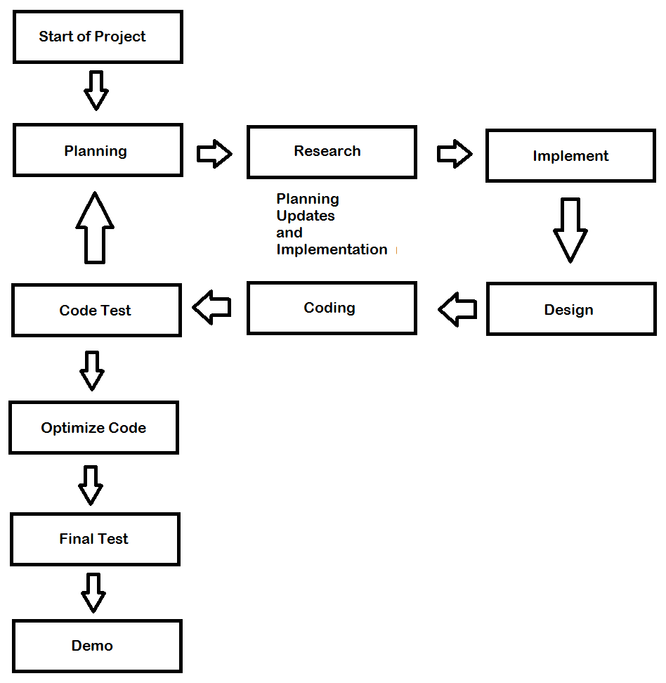

Figure 6.1.1 Process Model

6.2. Methods, tools, and techniques

Category | Methods and Techniques
Requirements | Meeting, Keeping updates
Analysis | UML Models: Use Case, Class Diagrams, Sequence Diagrams
Troubleshoot | Fixing code as faster as possible

Table 6.2.1 Methods and Techniques

Category | Tools
Operating System | Windows 7, 10
Software Application | Android Studio, Astah Community
Document | Microsoft Word, Microsoft Excel
Research | YouTube, Google

Table 6.2.2 Tools Used

6.3. Infrastructure Plan
Software needed in this project are as follows: Android Studio, Microsoft Word, and Astah Community. The said Software is an open source and can be access by the team.

6.3. Product Acceptance Plan
Phivolcs will test the application and run for an acceptance test. Phivolcs might request for an additional request for changes and improvements.

7. Supporting process plans

7.1. Configuration management plan
The team has Roles and Responsibilities to do their different task.

7.2. Verification and validation plan
The Team will go to Phivolcs and conduct a verification and validation survey. Phivolcs might request to have some changes and improvements of the app.

7.3. Documentation plan
Documents shall be complied for the semester. Each member shall check all the documents and verify if the documents is correctly reinforced.

7.4. Quality assurance plan
The tester makes sure that the application has no bugs and glitches so that the user will not having a bad time in using the app and make the user satisfied.

7.5. Reviews and audits
The team has no reviews and audits.

7.6. Problem resolution plan
If there is a problem, the team shall meet up and reinforce the problems automatically.

7.7. Subcontractor management plan
The team has no subcontractor management plan.

7.8. Process improvement plan
Each member shall discuss what have he done and what is lack of the code so that the team can reinforce and improve the lack of code of what the member discussed.

8. Additional Plans

9. Index

